43.50: Denote the reaction as
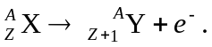
The mass defect is related to the change in the neutral atomic masses by
where 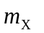and 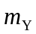 are the masses as tabulated in, for instance, Table (43.2).

